HCI Term Project Report
mCast


Thomas Kenny - 100737936
Adam Bielinski – 100743811

Dec 10th 2009

Table of Contents
- introduction 2
- objective 2
- design aspects 2
  - functionality 2
  - work overflow 2
- implementation details 3
  - technology 4
    - libraries 4
    - our own 4
    - Packet Packager 4
    - .Net 4
  - Graphical User Interface 5
    - Form Elements 5
- The Development Process 5
  - What worked 5
    - The UI 5
    - Connecting over the network 5
    - Git 5
    - Source control 5
    - Cross 6
  - What didn’t work 6
    - File recognition 6
    - Loss of packets 6
    - File corruption 6
    - Speed 6
    - Multiple files 6
- Conclusion 6

1.0 Introduction
This document is for the IMD 3004 class Human Computer interaction and Design. Our group consists of Thomas Kenny and Adam Bielinski. In this report we will cover overview of the goals that we were setting to achieve, the design aspects of our program, what technology we used and mainly what worked and what didn’t work in our final release.

2.0 Objectives
Our main objective for the program was to create a Multicast File Transfer System that would easily allow users to share files with multiple people without having the fear of slow transfer rate. Making the interface simple for everyone to use was the other main objective of the project, making it easy to use would make it appeal to the masses.

3. 0 Design Aspects

3.1 Functionality
mCast works as both a sender and receiver of files. The initial screen has both the file picking functionality of a file sending program as well as having a list of files available for receiving on the network.
If one wants to send a file, they would simply click the "Browse" button to locate the file. They would then be presented with a screen detailing who is connected and waiting for the transfer. Once all the local clients that the sender wishes to send to are connected, they would click the large "Begin Sending!" button. They would also have the option of offering a different file for sending and cancelling back to the initial screen.
Once the sending starts, no more clients can connect. The sender's screen transforms into a progress bar and cancel button. The progress bar displays roughly how much of the file is left to be sent. Once the file is done sending (according to our libraries functionality), the dialog reflects this and makes a sound, and the user has the option to continue back to the initial screen.
If the user decides to receive a file instead, they simply click on one of the files available on the network, and then click the "Get!" button. They are then presented with a file selection dialog titled "Save As...” and prompted if they would overwrite a file.
They then proceed to a dialog not unlike the progress report when sending a file. The user can cancel (corrupting a file) or wait until the transfer is done. A progress bar is used to report on amount remaining to download for the file. When this transfer is done, a dialog will pop up, and a sound is played. The user then again has the ability to return to the initial page.
Each user interface element has a descriptive tool tip displayed.

3.2 Work Overflow
When a user first boots up mCast they will be treated to an opening page where they choose whether or not to send a file or receive a file that is available on the network at the moment. From there if the user chooses to be sending a file the open file dialogue will open, after the file is chosen the Form will then show the information that the current Sender is trying to send and the mCast will start projecting that the file is on the network. From there if the user decides to send the file they click the send button and the program starts sending it.
If the user is looking to get a file first they have to wait for a file to appear in the file window. Then when the click the get file button they have go to a form that shows them some more detail about the file that they are about to download. Also on this screen they decide where to save the file which is greeted by a save file dialogue and once a place is chosen the next window will allow the user to start receiving the file.
(Refer to figure 1.0) 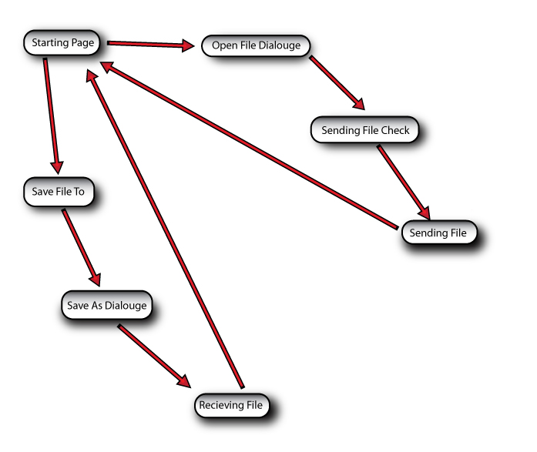
Figure 1.0

4. 0 Implementation Details

The project uses technology that can be found in Visual Studio. There are essentially two components to the program: The visual front end, and a data back end. The front end was created using Visual Studio, while the back end was coded using Monodevelop. The project was managed using Git, with the repository being stored on GitHub.
The school network does not allow multicast. All computers connected to this network are also firewalled, and do not allow any programs to open a UDP listening port. This makes it impossible to use our program on any lab computer.

4.1 Technology

C# and .NET have some support for multicast, but any protocol built on such a UDP technology must be created by oneself. There are no helper libraries.

4.1.1 Libraries
We did not use any external libraries apart from our own. There were none available.

4.1.2 Our Own
Our own library was created to send files over multicast. This involved coming up with a protocol, an understanding basic UDP networking, and other technologies.
The basis of our main "Controller" object is a networking object that has a receiving thread. This thread pushes every received chunk on to a stack so that another thread may pop them off (there is no shift operation in C#).
The Controller object is designed to be run either in the same thread as your GUI thread, being polled on a timer, or be run in a separate thread. The class is, as of this writing, not thread safe and cannot be run in its own thread as of yet.
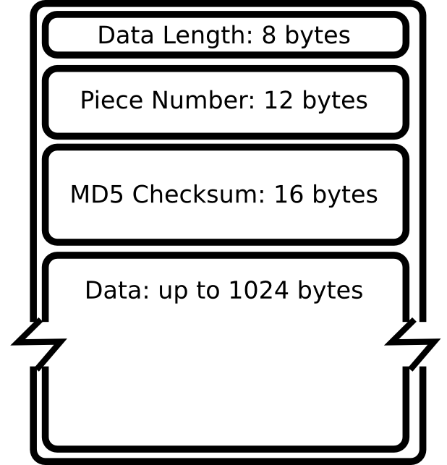
4.1.3 Packet Packager
The library contains a FilePiece class that effectively composes and parses the packets for and from the networking object. Creating this object had to be done very carefully, and an understanding of byte arrays was certainly required. (Packet in figure 2.0)
The FilePiece class uses an MD5 sum to verify that packets are uncorrupted.
Each piece is numbered. The number signifies which section of the file the piece is from. The calculated position is the number times the data length in bytes.

Another class handles writing and reading the file in question called FileStreamer. It handles writing and seeking a file. This is likely extremely slow, and not coded entirely to code, but it works.

Figure 2.0

4.1.4 .Net
The .NET libraries contain a Sockets class that is used to communicate over the network. Please note that this library throws seemingly random exceptions if a network connection is lost at any point. This may cause mCast to slow down.

4.2 Graphical User Interface

4.2.1 Form Elements
There are many different form elements that we used to get the Forms working.

Progress bar - used to show the amount that the file has been sent or received.
Buttons - obviously used to set off functions and other navigational changes.
List box - used to list the files availably and possibly the people sending the file.
Tooltip -used to help the user navigate the mCast program.
TableLayoutPannel - used to store the different "windows" that mCast navigates through.

Interface Overview
Interaction (?)
Networking
Sending the files
Receiving the files

5.0 The Development Process
5.1 What Worked
5.1.1 The UI
The GUI worked out in many respects, mainly the fact that the whole program is taking place in only a single form. This was for ease of use for the coding; having everything take place in one form meant that there would be little to no variables needed to be passed from one Form to another.
For the whole program to take place in a single form there were some changes that had to be made. All the windows are actually elements put in a table and when a different “form” needs to be shown it hides the current one and show the one that will be on screen. The form was then resized to just bigger than the table size so that it fits snugly. Tooltips were added to help the user navigate through the mCast easily.

5.1.2 Connecting over the network
The program successfully sends and receives packets, as well as encoding and decoding these packets. It works well enough.

5.1.3 Git
Git was a huge help. It allowed us to easily share the code and work (including this report) between any and all computers we were working on.

5.1.4 Source control
The ability to roll back changes and make branches saved us a few times. Source control should be required for all software projects.

5.1.5 Cross platform development
It was interesting to work on two different platforms with incompatible user interfaces. It was required to use the Windows Forms to generate the interface, but of course this can only be compiled on windows (easily). So for the Linux machine, a command-line interface was developed. This did not take more than an hour to generate, and in doing so, exposed a number of flaws in the library's coding.

5.2What Didn't Work

5.2.1 File recognition
We haven't yet implemented any sort of file type information that is sent to the clients. This prevents the client from really knowing what kind of file they are getting. For instance, the client could accept a transfer from a server for a movie called "movie.avi", but save it as "movie.txt". If the client opens this by double-clicking, it will open in a text editor and will not function correctly.

5.2.2 Loss of packets
It is impossible to say why due to the nature of UDP, but currently some packets get lost in transit. There is an algorithm that gets the client to request these missing packets. This currently does not work at 100% and some packets are never received, corrupting the file occasionally.

5.2.3 File Corruption
Currently there is a bug in the protocol, where the checksum does not check the integrity of the entire packet, but only the data itself. This means that some correct data could end up in an incorrect place in a file.

5.2.4 Speed
Currently the speed of the transfer is artificially low. This is because we really don't know how fast to make it. It also makes bug testing easier.

5.2.5 Multiple files
Currently the "file selection" that the receiver does is useless. Only one file can be sent on a network at once. This can be fixed by either giving each file a unique identifier that is sent along with the packets, or by putting each file transfer on a different multicast address and/or port. Both would require some modification of the protocol.

6.0 Conclusion
The overall development of mCast was a two faced ordeal. Sometimes development went smoothly while when problems did arrive they were difficult to decipher but usually there was a simple fix. There were a few times that ideas had to be rethought through to be solved but these solutions did not take too long to implement.

